**CMPSC 201**

**Project 2 Report**

**974343924, 906694475 – Ibrahim Ibrahim, Youssef El Minawi, Diego Santacruz(**p.s he did not participate)

**October 10, 2018**

**Pseudocode**

Write a C++ program that computes the discriminant of a quadratic equation in the form *ax2 + bx + c = 0*. Then use this to tell the user how many solutions the equation has and what kind of solutions there are.

**Code**

#include<iostream>

#include<math.h>

using namespace std;

int main()

{

double a;

double b;

double c;

double D;

double x;

double y;

cout << "This program was written to assist you solving your polynomials. Enter your numbers in the form ax^2+bx+c=0. Enter a, b, c";

cin >> a;

cin >> b;

cin >> c;

D = (b*b) - (4 * a*c);

cout << "The Discriminant is " << D << endl;

if (D>0) {

cout << "This equation has two real solutions" << endl;

}

else if (D == 0) {

cout << "This equation has one real solution" << endl;

}

else if (D<0) {

cout << "This equation has two imaginary solutions" << endl;

}

if (D >= 0) {

x = ((-b) + sqrt((b*b) - (4 * a*c))) / (2 * a);

y = ((-b) - sqrt((b*b) - (4 * a*c))) / (2 * a);

cout << "The first solution is = " << x << endl;

cout << "The second solution is = " << y << endl;

}

return 0;

}

**Code Sample Runs**

One Real Solution:

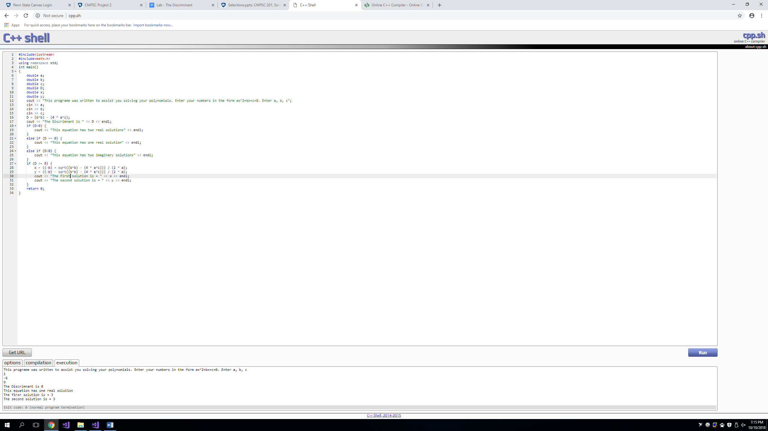

Two Real Solutions:

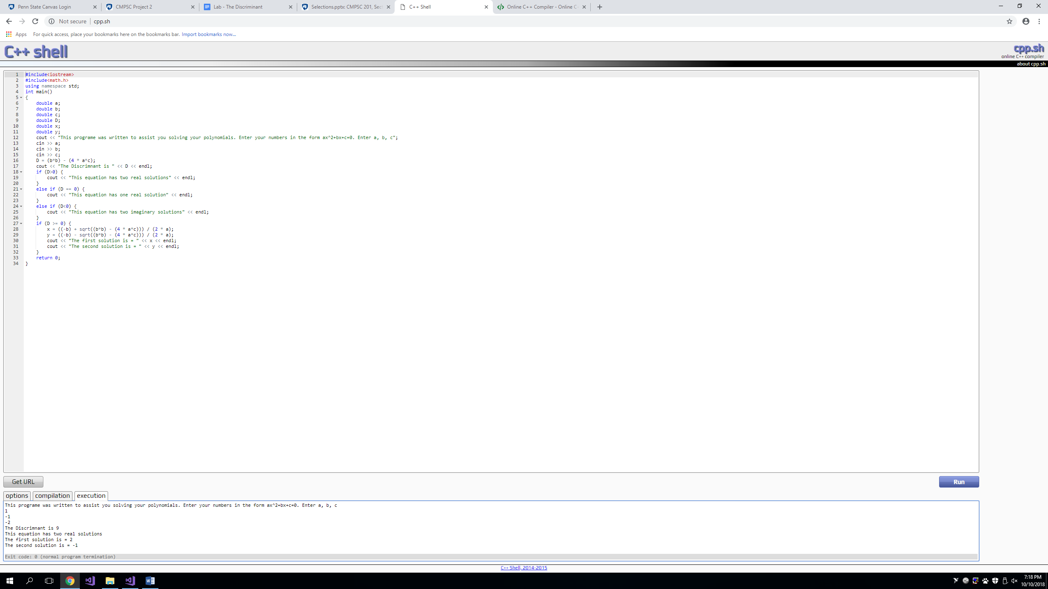

Two Imaginary Solutions:

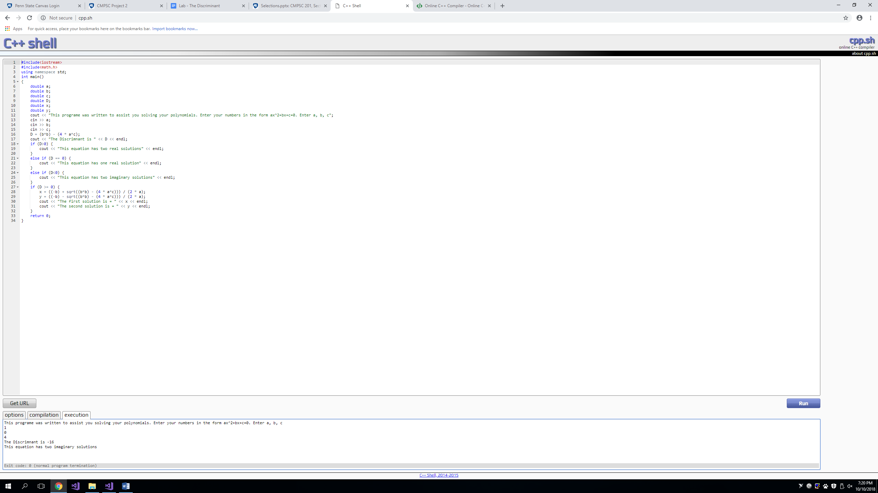

**Discussion**

Our expectations were to write a three part code, solving a polynomial and describing the conditions of its roots. We did meet the expectations by writing an exceptional piece of code that describes the purpose of the program to the user and as well takes the appropriate inputs and putting them to the proper usage within the written code. The code first asks for the coefficients of the polynomial and then assigns each value, a, b, and c into the appropriate sections of the quadratic equation. After the program solves the discriminant within the quadratic equation, determining whether the roots of the polynomial are two real unequal roots, two complex imaginary roots, or a multiplicity of 2. After determining the number of the solutions and their type, the program goes on to solve for the roots of the polynomial if it determines the polynomial has one real solution or two real solutions.